
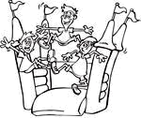
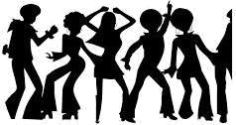
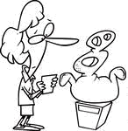
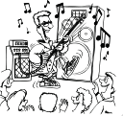
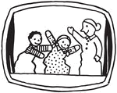
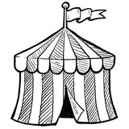
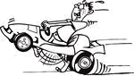
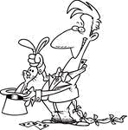
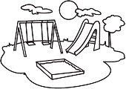
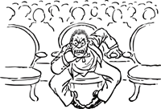
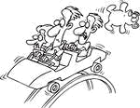
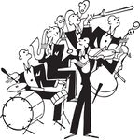
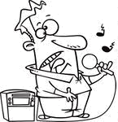
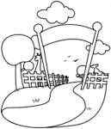
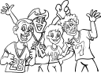
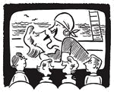
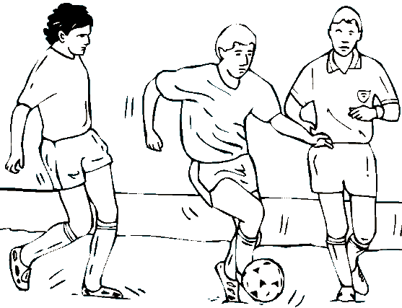
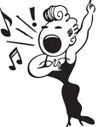
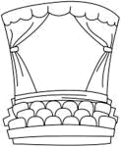
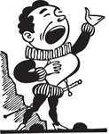
Choose the correct option.
a) pop concert
b) disco
c) bouncing castle

a) opera
b) pop concert
c) cinema

a) magic show
b) game show
c) puppet show

a) disco
b) circus
c) concert

a) museum
b) playground
c) theatre

a) puppet show
b) magic show
c) game show

a) fans
b) visitors
c) audience

a) circus
b) cinema
c) disco

a) amusement park
b) zoo
c) playground

a) football match
b) go-kart track
c) bouncing castle

a) amusement park
b) playground
c) circus

a) artists
b) visitors
c) fans

a) karaoke bar
b) game show
c) magic show

a) opera
b) circus
c) concert

a) zoo
b) circus
c) amusement park

a) cinema
b) playground
c) theatre

a) artist
b) pop star
c) fan

a) theatre
b) cinema
c) circus

a) rock concert
b) puppet show
c) opera

a) concert
b) football match
c) museum

